

National Textile University

**Department of Computer Science**

Subject:

Operating System

Submitted to:

Sir Nasir

Submitted by:

Asbah Asif

Reg number:

23-NTU-CS-1141

Lab no: 02

Semester: 5th

**Lab Work:  
Commands on Ubuntu practice:**

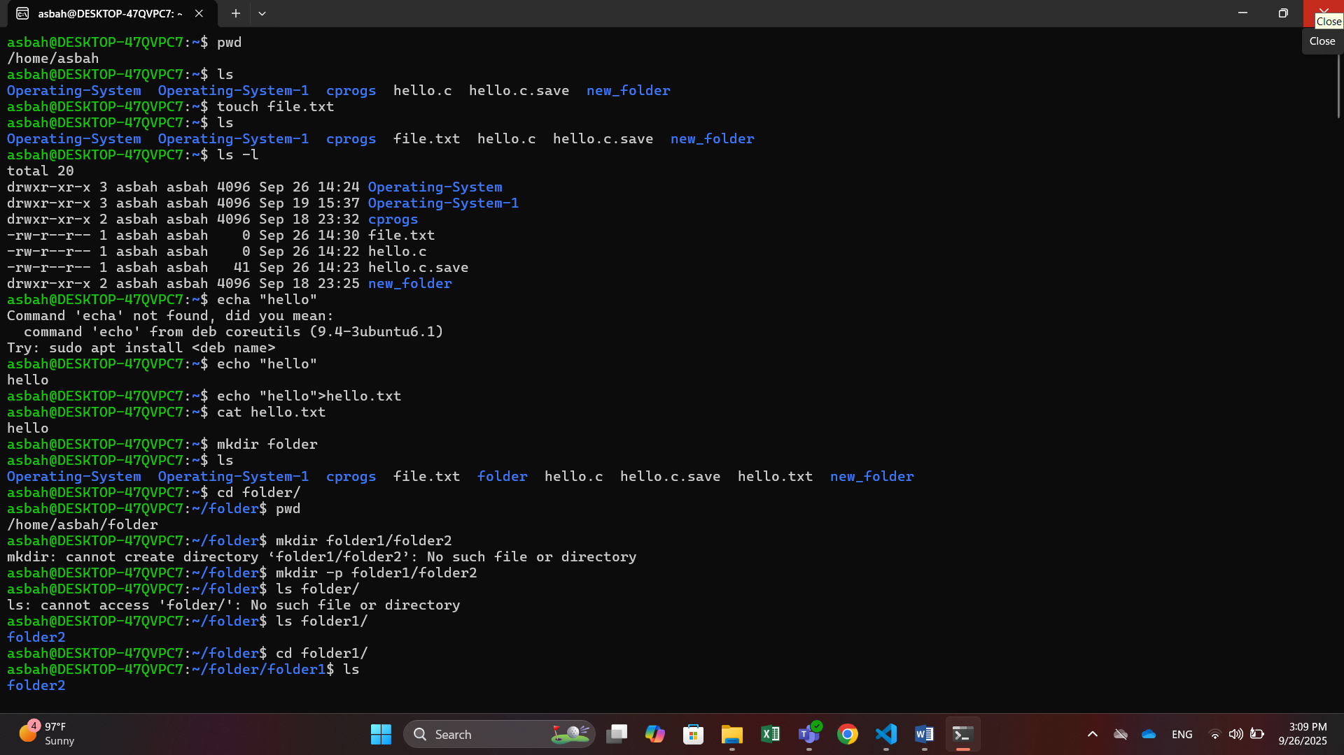

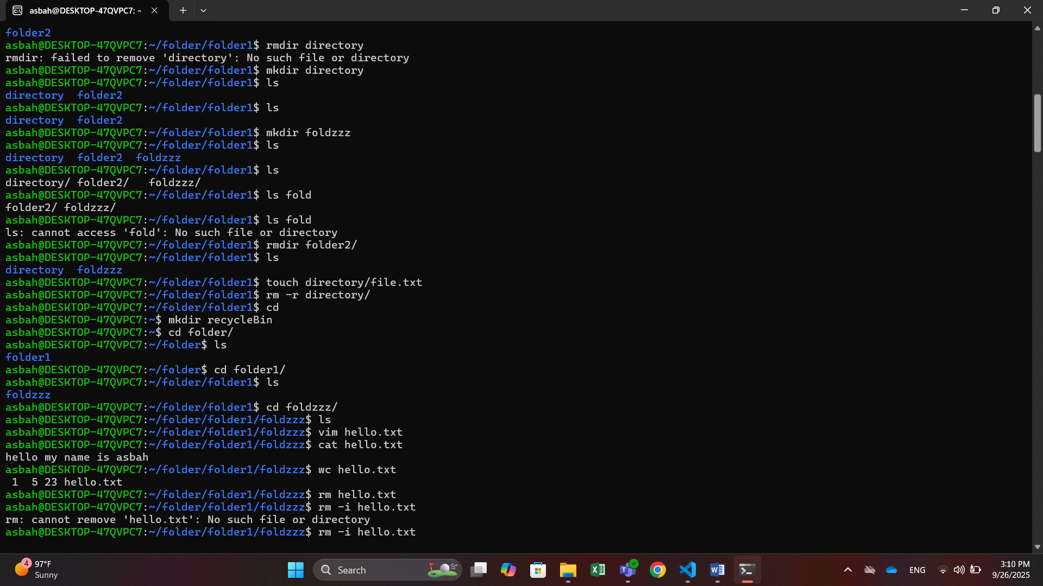

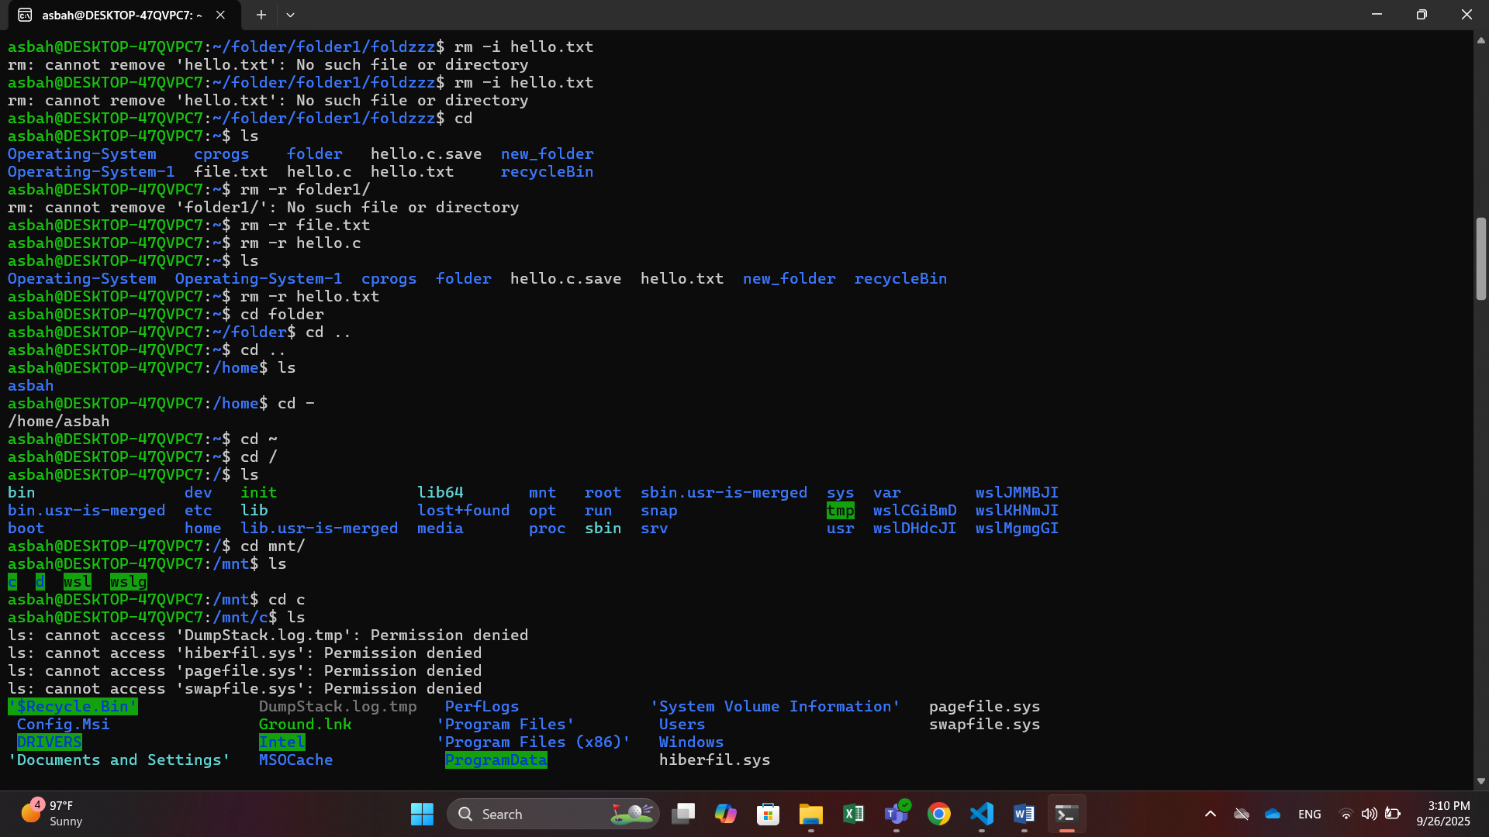

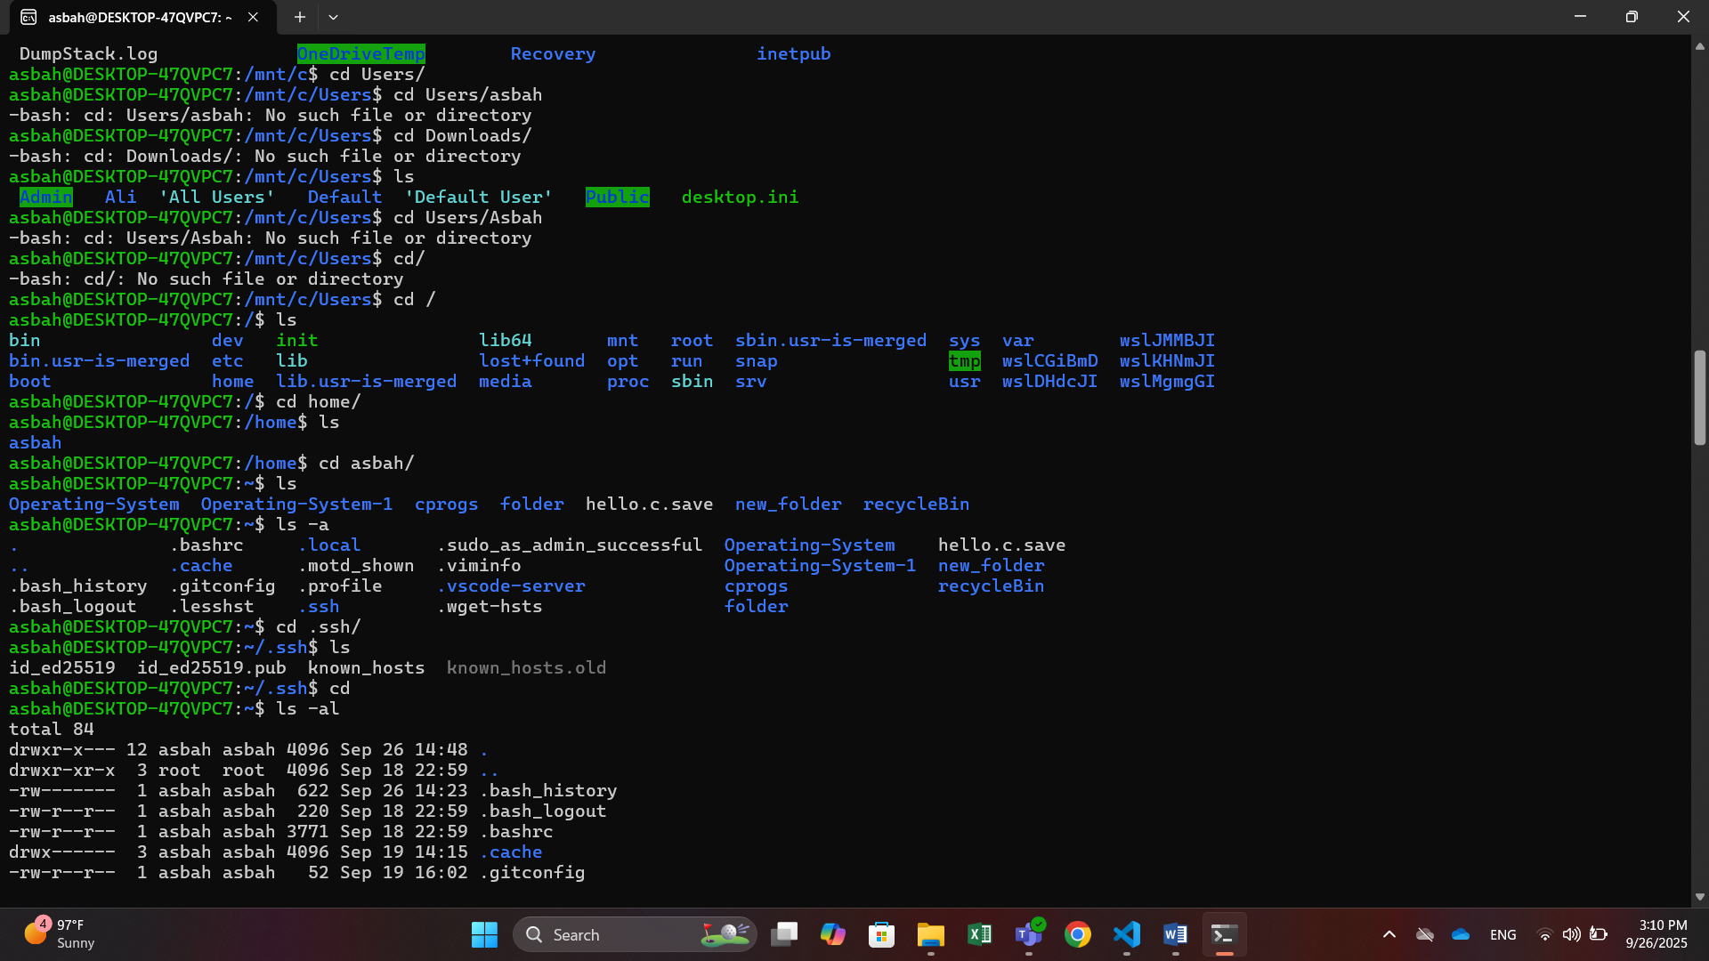

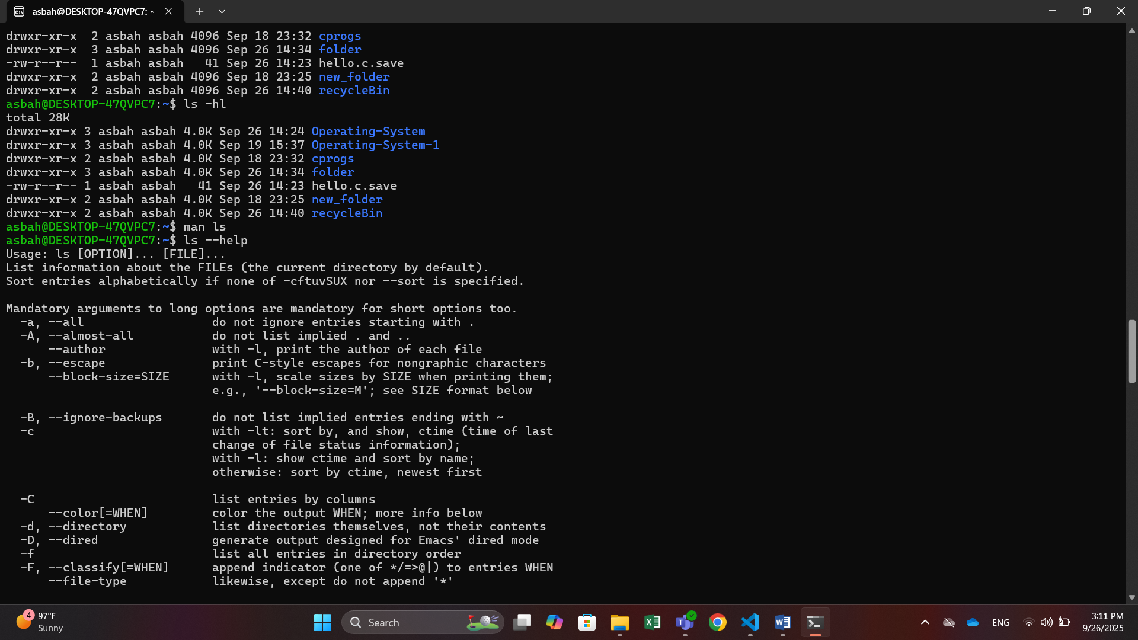

**Part 1:  
1.1:**

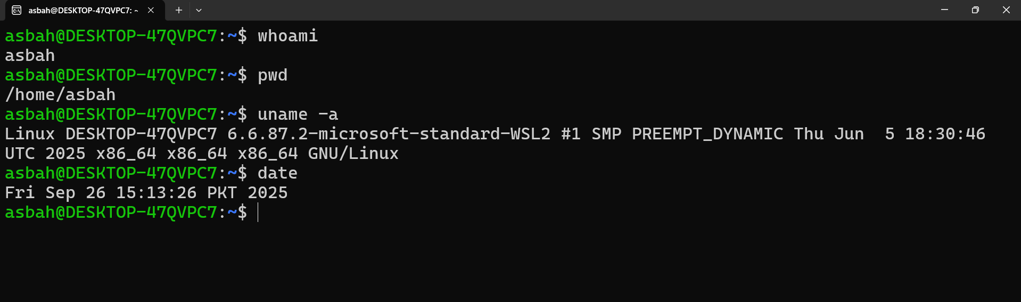

**1.2:**

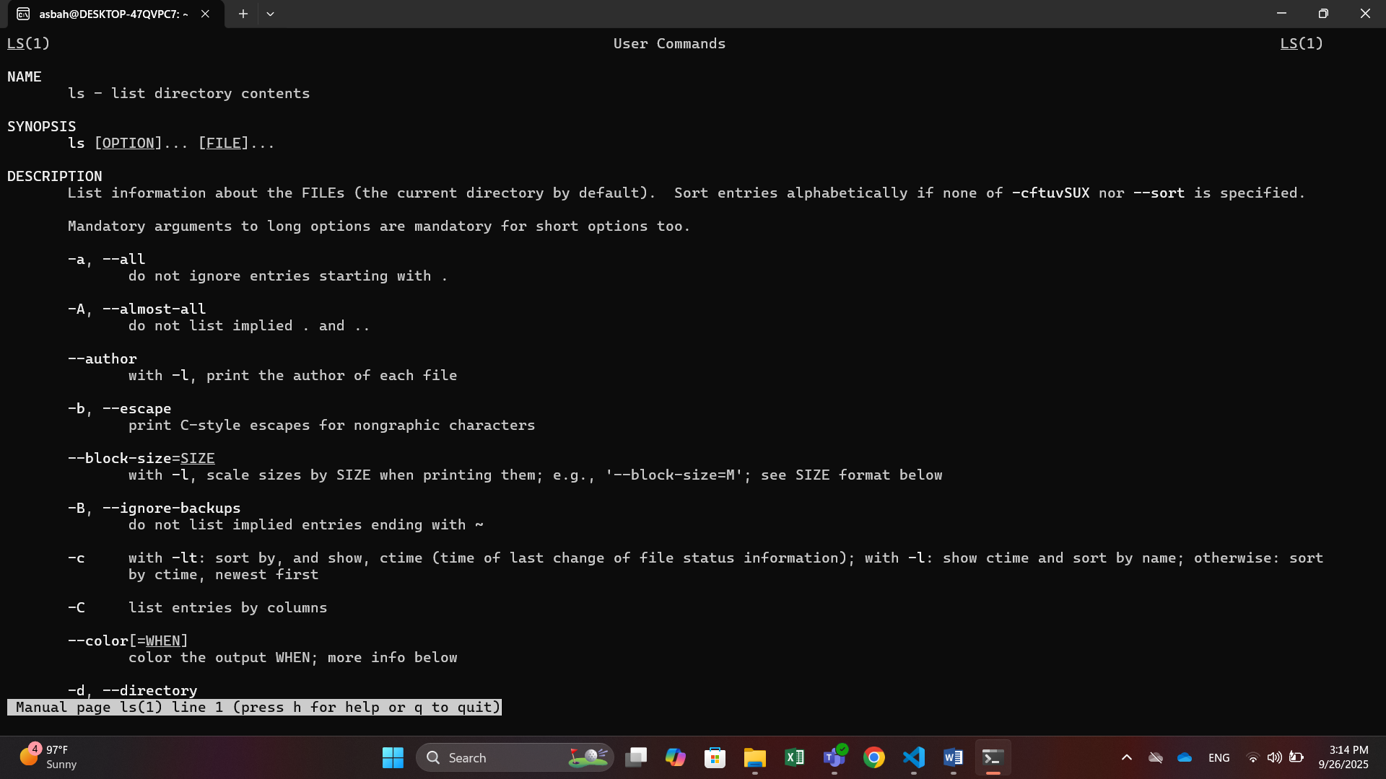

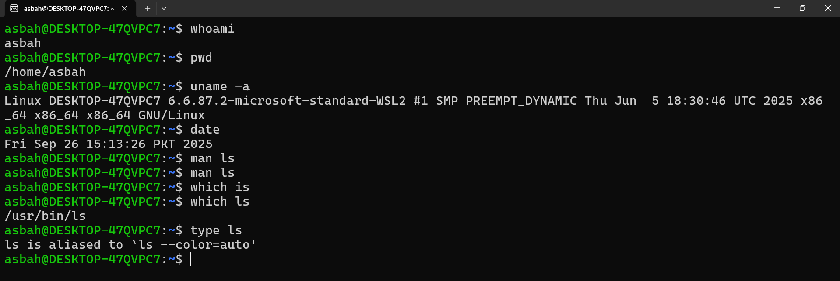

**Part 2: File System Navigation**

**2.1**

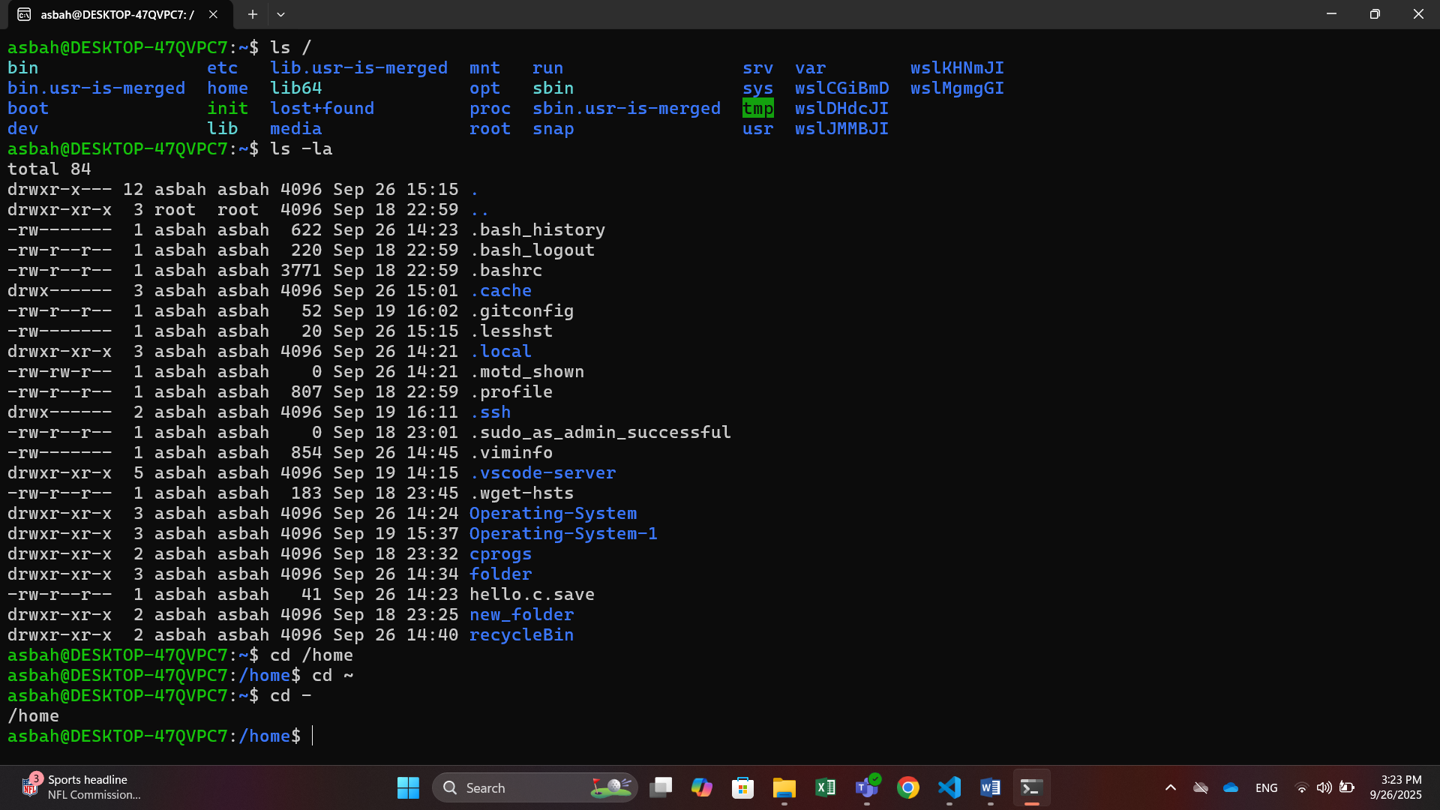

**2.2**

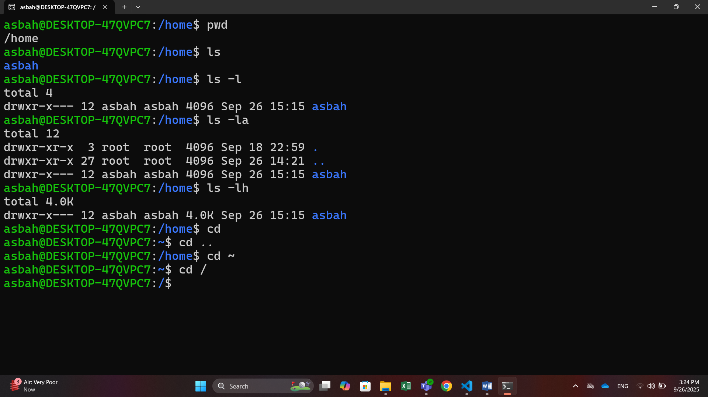

**Part 3: File & Directory Operations**

**3.1**

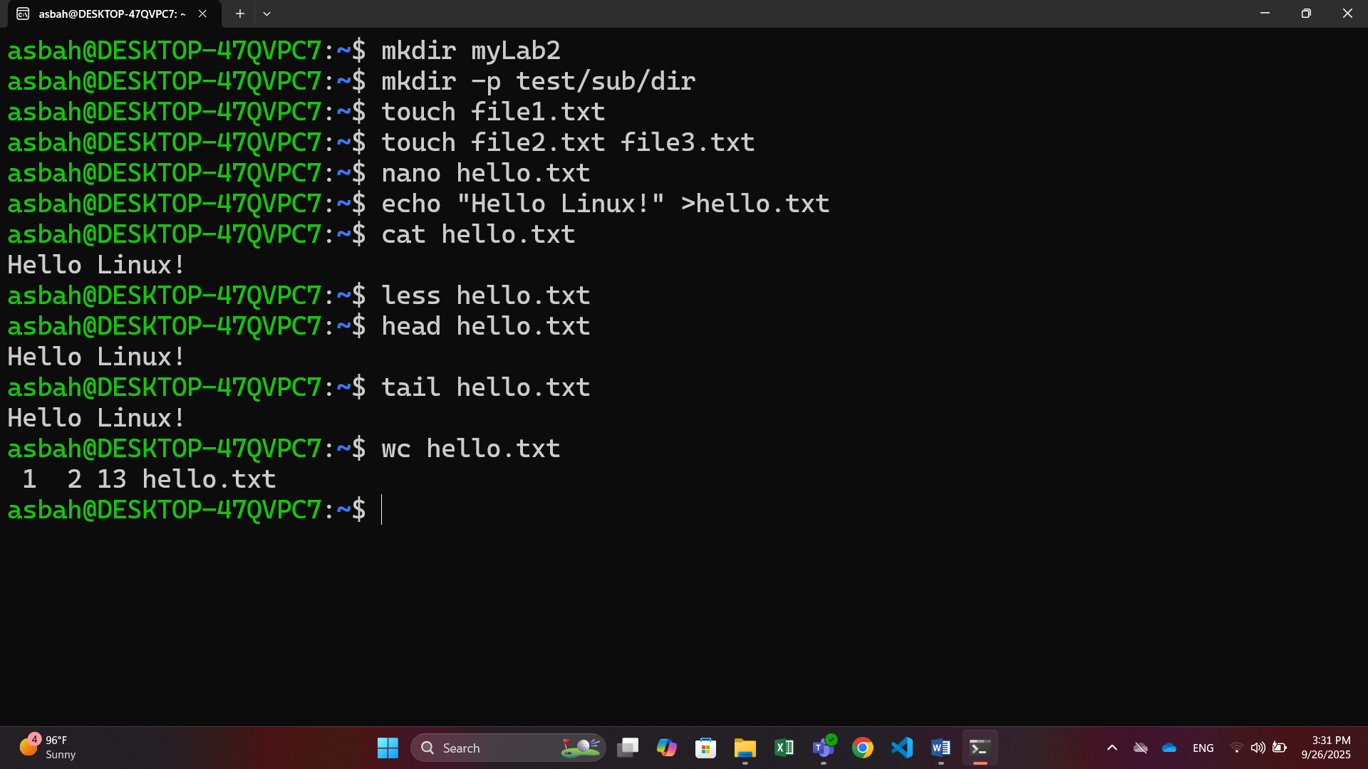

**3.2**

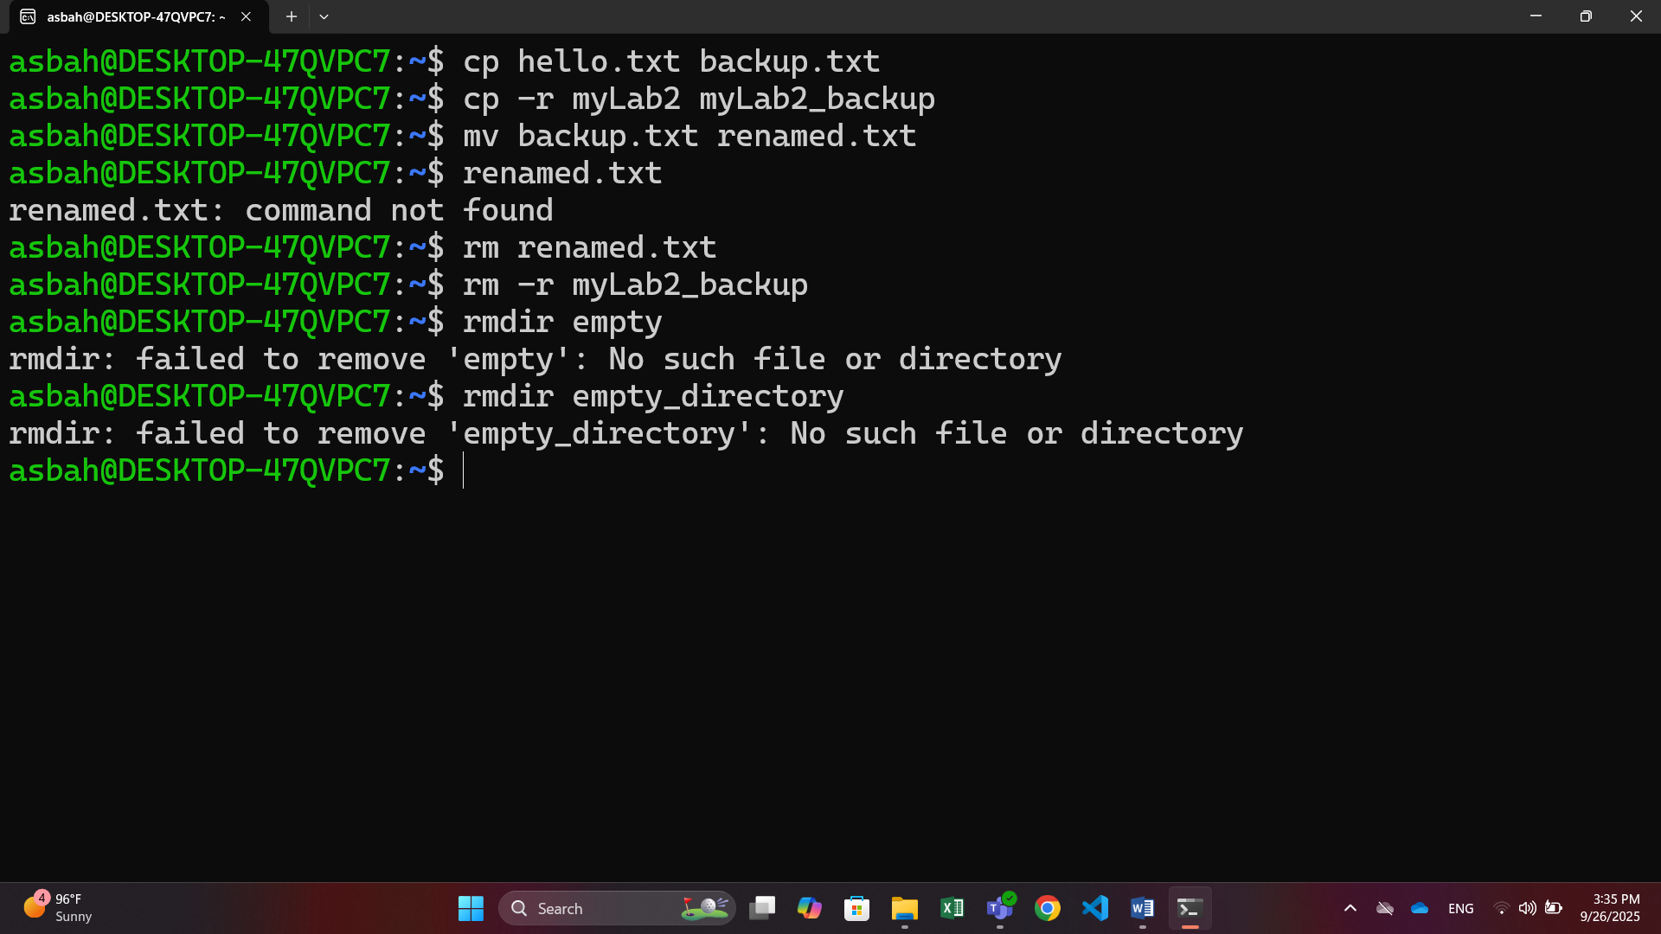

**Part 4: File Permissions & Ownerships**

**4.1**

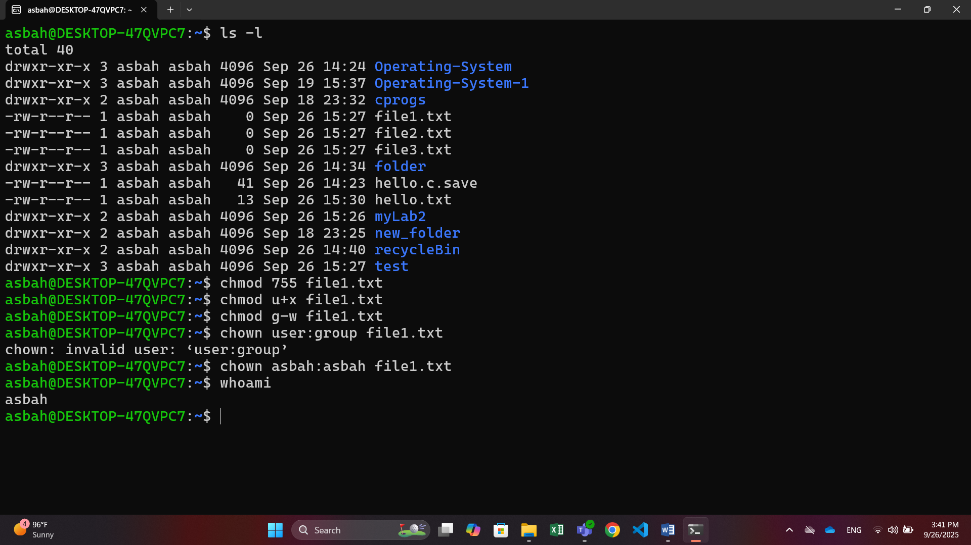

**Part 5: Text Processing and Utilities**

**5.1**

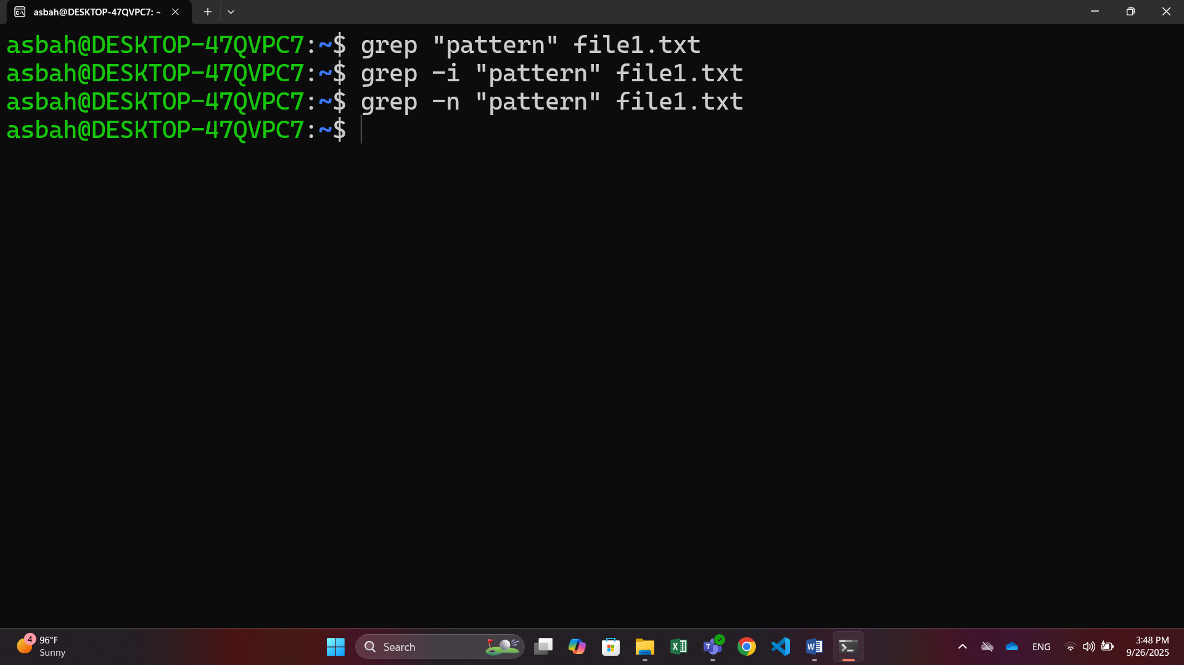

**5.2**

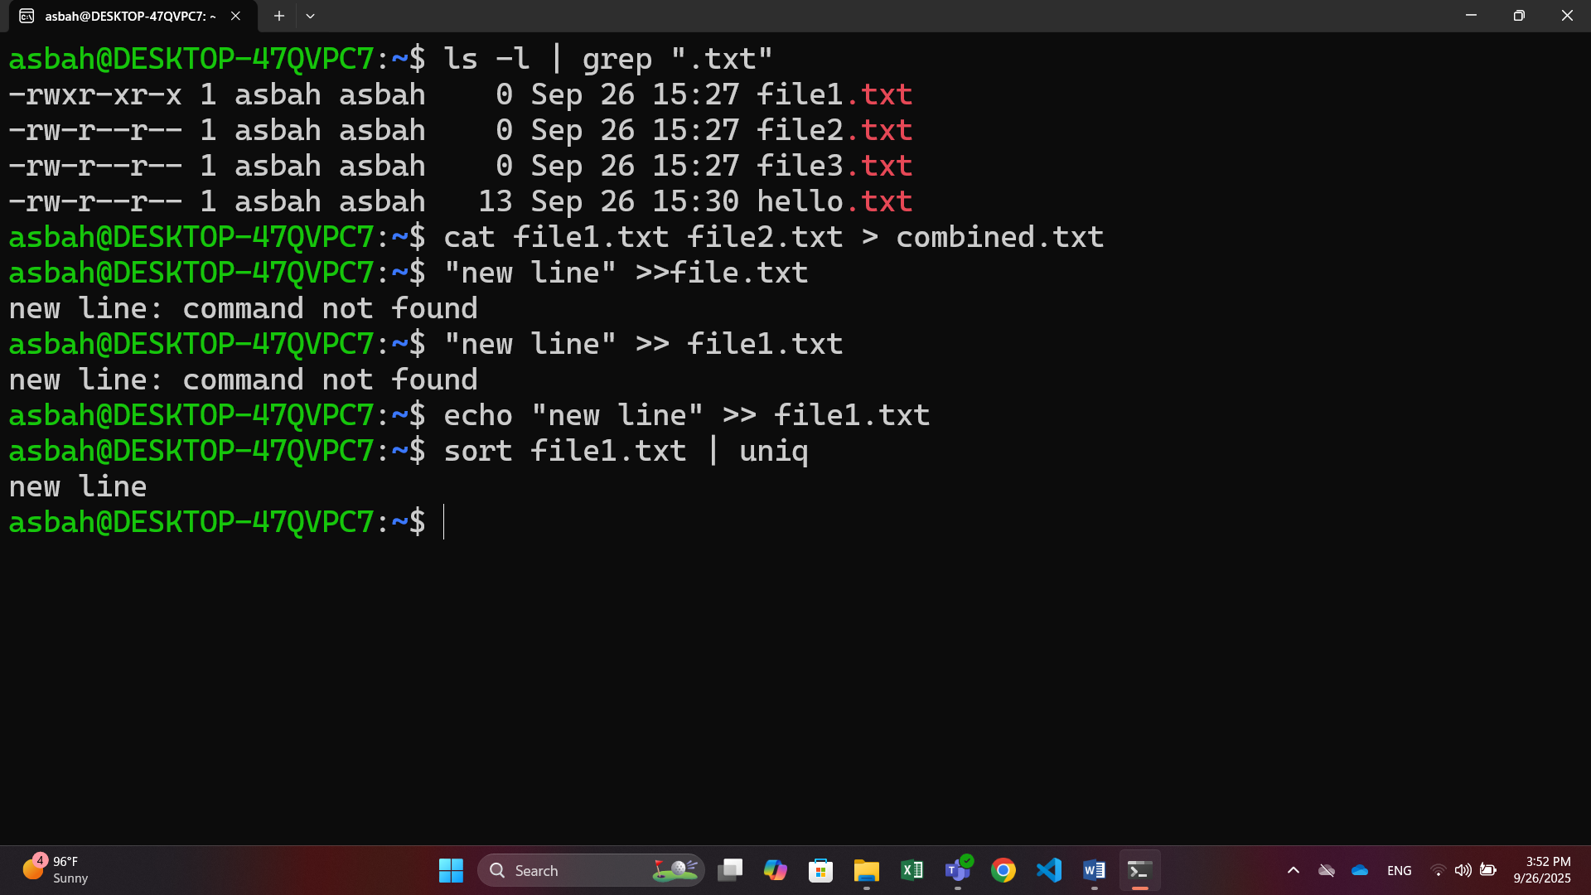

**Part 6: Introduction to Processes**

**6.1**

